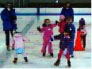
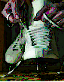
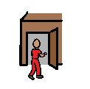
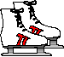
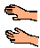
1
2
3
4
5
6
skate
arrive at the
skating rink
get skates

time to say
goodbye
have hot cocoa
and pizza

